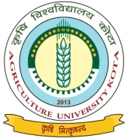

Krishi Vigyan Kendra : Hindauncity (Karauli)
Agriculture University Kota

Extension Achievements 2014-15 to 2016-17

Name of KVK: Hindauncity (Karauli) Year of establishment : 2004
1. Total training courses conducted

Years | Farmers & Farm Women |  |  |  |  |  | Field Functionaries |  | Rural Youth |  | Sponsored
Years | On campus |  | Off campus |  | Total
Years | No. | Part. | No. | Part. | No. | Part. | No. | Part. | No. | Part. | No. | Part.
2014-15 | 14 | 306 | 23 | 449 | 37 | 755 | - | - | 06 | 133 | 25 | 657
2015-16 | 07 | 160 | 27 | 582 | 34 | 742 | 01 | 25 | 03 | 67 | 44 | 1250
2016-17 | 11 | 265 | 14 | 331 | 25 | 596 | - | - | - | - | 57 | 1660
Total | 32 | 731 | 64 | 1362 | 96 | 2093 | 01 | 25 | 09 | 200 | 126 | 3567

2. Frontline Demonstrations conducted (2014-15 to 2016-17)

Performance of FLD (Oil Seeds)
S.No. | Crop | Technology Demonstrated | Variety | No. of Farmers | Area (ha.) | Yield (q/ha |  | % Increase over FP | Increase in Net retun (Rs.ha) over FP
 |  |  |  |  |  | Demo | FP | % Increase over FP | Increase in Net retun (Rs.ha) over FP
 | 2014-15
1 | Mustard | Improved Seed | NRCDR-2 | 30 | 15 | 16.8 | 14.6 | 15.07 | 5290
2 | 2015
 | Seasme (TIL) | Improved Seed | RT-346 | 20 | 10 | 5.76 | 4.60 | 25.22
3. | 2015-16
 | Mustard | Improved Seed | RH-749 | 75 | 30 | 16.04 | 14.0 | 14.57 | 6202
4. | 2016-17
 | Mustard | Improved Seed | NRCDR-2 | 100 | 45
 | Total |  |  | 225 | 100

Performance of FLD (Pulses)
S.No. | Crop | Technology Demonstrated | Variety | No. of Farmers | Area (ha.) | Yield (q/ha |  | % Increase over FP | Increase in Net retun (Rs.ha) over FP
 |  |  |  |  |  | Demo | FP | % Increase over FP | Increase in Net retun (Rs.ha) over FP
 | 2014
1. | Moong | Improved Seed | GM- 4 | 20 | 10 | 12.3 | 10.4 | 18.27 | 8540
2. | 2014-15
 | Gram | Improved Seed | CSJD- 884 | 20 | 10 | 14.1 | 12.1 | 16.53 | 4700
3. | 2015-16
 | Gram | Improved Seed | GNG- 1581 | 40 | 16 | 18.0 | 15.2 | 18.42 | 10250
4. | 2016-17
 | Greengram | Improved Seed | IPM-02-03 | 50 | 20 | awaited
 | Gram | Improved Seed | GNG- 1581 | 50 | 20
 | Total |  |  | 180 | 76

Performance of FLD (Cereals)
S.No. | Crop | Technology Demonstrated | Variety | No. of Farmers | Area (ha.) | Yield (q/ha |  | % Increase over FP | Increase in Net retun (Rs.ha) over FP
 |  |  |  |  |  | Demo | FP | % Increase over FP | Increase in Net retun (Rs.ha) over FP
 | 2014-15
1. | Wheat | ImprovedSeed | Raj.-4037 | 20 | 10 | 51.2 | 45.6 | 12.28 | 7270
2.

Performance of FLD (Other demonstrations)
S.No. | Crop | Technology Demonstrated | Variety | No. of Farmers | Area (ha.) | Yield (q/ha |  | % Increase over FP | Increase in Net retun (Rs.ha) over FP
 |  |  |  |  |  | Demo | FP | % Increase over FP | Increase in Net retun (Rs.ha) over FP
 | Wheat | Thio-urea | Raj-4037 | 28 | 14.0 | 45.20 | 40.50 | 11.60
1. | 2014
 | Guar | Improved Seed | RGC-1017 | 20 | 10 | 11.9 | 10.3 | 15.53 | 5660
2.
3.

3. Information of On farm testing conducted during last three years
S.No. | Name of Crop/enterprises | Technology assessed/refined | Final recommendations
 | 2014-15
1. | IDM | Seed treatment with Trichoderma @ 6.0 g/kg seed and soil application of Trichoderma @ 2.5 kg/ha with FYM. In gram | seed treatment and soil application of Trichoderma recorded lowest disease intensity (1.63) with 64.38 % disease control compared to Farmer’s practices
2. | 2015-16 | NIL
3. | 2016-17 | Azolla @ 1.5kg/day head and reduce quantity of 1kg concentrate from previous quantity | 39.28% increase in milk yield

4. Farmers scientist interaction
S.No. | Name of activities | No. | No. of beneficiaries
 | 2014-15
 | Farmer-Scientist Interaction |  | 30
 | Farmer-Scientist Interaction |  | 30
 | 2015-16
 | Farmer-Scientist Interaction |  | 35
 | Farmer-Scientist Interaction |  | 29
 | 2016-17
 | Farmer-Scientist Interaction |  | 203
 | Farmer-Scientist Interaction |  | 203
7. | Farmer-Scientist Interaction |  | 203
 | Total | 07 | 327

5. Information of Extension Activities conducted

S.No. | Name of activities | No. of activities |  |  |  | No. of beneficiaries
 |  | 2014-15 | 2015-16 | 2016-17 | Total | 2014-15 | 2015-16 | 2016-17 | Total
1. | Field days organized | 04 | 06 | 12 | 22 | 102 | 269 | 652 | 1023
2. | Kishan Gosthi | 01 | 05 | 02 | 08 | 28 | 374 | 179 | 581
3. | Diagnostic visit | 09 | 05 | 03 | 17 | 31 | 45 | 21 | 98
4. | Scientific visit to farmers field | 73 | 81 | 73 | 227 | 336 | 451 | 649 | 1436
5. | Farmers visited to the KVK | - | - | - | - | 577 | 556 | 713 | 1846
6. | Kishan Mela organized | - | - | 01 | 01 | - | - | 670 | 670
7. | Kishan shivir (Rabi, Kharif) | - | - | 02 | 02 | - | - | 170 | 170
8. | Telephone help line | - | - | - | - | - | - | 493 | 493
9. | Press news coverage | 21 | 26 | 18 | 65 | - | - | - | -
10. | SHG formation | - | - | - | - | - | - | - | -
11. | Exhibition | 10 | 12 | 11 | 33 | 556 | 561 | 6864 | 7981
12. | Lectures delivered | 81 | 265 | 308 | 654 | 1006 | 3556 | 2767 | 7329
13. | Exposure visits | - | - | - | - | - | - | - | -
14. | Animal Health Camp | 02 | 02 | 02 | 06 | 77 | 450 | 1230 | 1757
15. | Soil test campaigns | - | - | - | - | - | - | - | -
16. | Celebration of important days (specify)* | 04 | 03 | 04 | 11 | 108 | 317 | 171 | 596
17. | Any other
18. | Film Show | 12 | 9 | 11 | 32 | 396 | 345 | 1045 | 1786
19. | Technology week organised | - | - | - | - | - | - | - | -
20. | Method demonstration | 02 | 06 | 02 | 10 | 08 | 12 | 11 | 31
21. | Group meeting | 01 | - | 02 | 03 | 24 | - | 68 | 92
22. | RAWE | 01 | 01 | 01 | 03 | 50 | 45 | 08 | 103
23. | Literature distributed | 565 | 1565 | 16550 | 18680 | - | - | - | -
*ICAR foundation day,Jai Kissan Jai Vigyan divas,Soil health day.

6. Information on Extension literature & other publication
S.No. | Type of publication | No of publication |  |  | Total
 |  | 2014-15 | 2015-16 | 2016-17 | Total
 | Research Paper | - | - | - | -
 | Popular article | 03 | 01 | 01 | 05
 | Training manuals | - | - | - | -
 | Technical bulletin/ folders | 02 | 05 | - | 07
 | Other (If any) | - | - | - | -

7. Impact of KVK activities (during last 3 years)

Name of specific technology/skill transferred | No. of participants | % of adoption | Change in income (Rs.)
Name of specific technology/skill transferred | No. of participants | % of adoption | Before (Rs./Unit) | After (Rs./Unit)
Preservation of fruit &Vegetable | 180 | 20-25 | 0.00 | 3000-3500
Ladies Tailoring. | 85 | 70-80 | 0.00 | 2000-2500
Value addition | 500 | 20-25 | 0.00 | 2000-2500

8. Success stories (at least two with good working photographs)Attached
Success Story-01
1. Situation analysis: -Kamlesh belong to Revai village. Due to poor financial condition, she could hardly fulfil the family member’s requirement. Tailor Ladies work is important field for self employment especially for women. At present stitching work is more costly therefore a wide place for self employment. In the Karauli district most of population living in rural areas and the district fall in tribal belt &dang, hilly area. The lack of population literacy in rural and in the rural women it has very less so that type vocational training is very important not only for self employment but also women empowerment.
1. Name of the Enterprise: - Smt. KamleshW/O Shri Ram kumar  Vill- Ravai Post-Mahu,Teh- Hindaun City  Distt. Karauli (Raj.) Mob. No. 9983961735  Age- 35 year  Cast- Jat (O.B.C) | 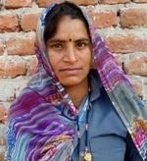

2. Plan, Implement and Support: - She has been trained through 80 Days vocational training of Tailor Ladies. After 80 days vocational training on tailor ladies conducted by KVK, and discussion with Extension Scientist she became motivated towards stitching work on her village. .
3. Out Put and Outcome: - She was unemployed before the training but after the training her improve the skills in the tailoring field and KVK Extension scientist also motivate to her for self employment and now she is getting 8000/ Rupees per month to the tailoring job. She is also trained to rural girls in summer and winter vacation and leader of self help group.

4. Impact: - Kamlesh get nil rupees before job but after training she start self entrepreneur and now she earning about Rs.8000/per month .
action photos of enterprise are enclosed.
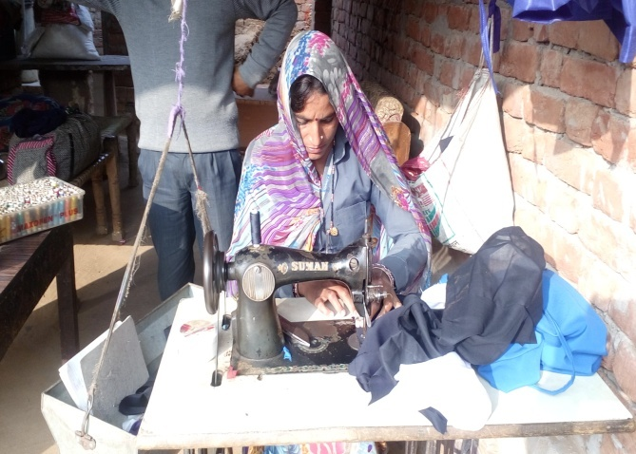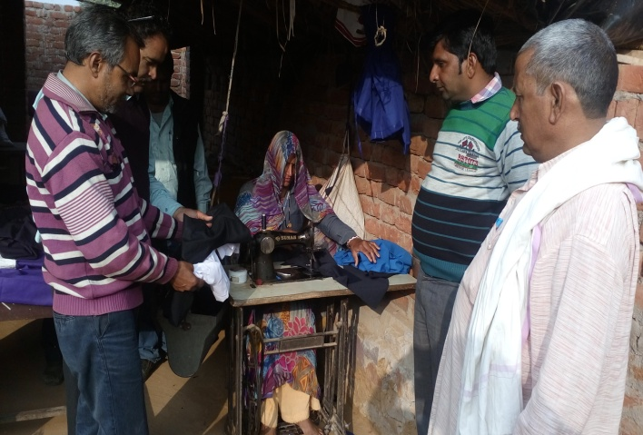

Collected and edited by: - Dr. R.K. Meena
Scientist Extension Education, KVK Hindaun (Karauli )

Krishi Vigyan Kendra, Hindaun (Karauli)
Agriculture University, Kota (Raj.)
Success Story-02
2.Plan, Implement and Support : - Virendra Singh has been trained through 40 Days vocational training of Krishi Jankar. he was unemployed before the training but after the training he improve the skills in the Horticulture and Vegetable field and KVK Extension scientist also motivate to him for self employment. In this motivation virendra established a 2000sq meter poly house with help of Horticulture department.
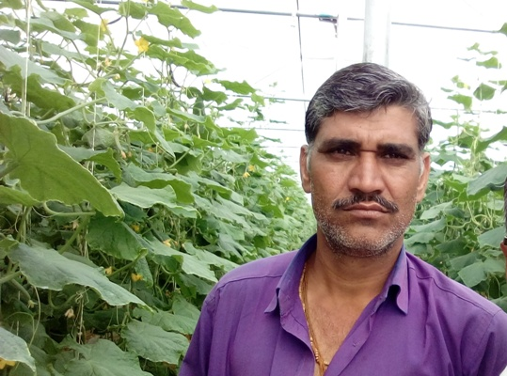1. Name of the Enterprise:-
Virendra Singh S/O Shri Bhagwan Singh
Village- Akorashi Post-Jatnangla,
Teh- Hindaun City
Distt. Karauli (Raj.) Mob. No. 9784608227
Age- 38 year
Cast- Jat (O.B.C)

1Situation analysis/ Problem Statement:-Virendra singh jat lives in Akorashi village and he has 10 bigha land. Wheat, Mustard in rabi and Bajra cultivation in kharif as a routine crop. He was not satisfying his income. He has keen interest in Horticulture and vegetable crops and willingness to do something new. Virendra has an innovative nature and he participated in training, Demonstration, dairy, krishi jankar training and other extension activities conducted by KVK.
Horticulture and vegetable farming work is important field for self employment especially for rural youth and women. At present fruit and vegetables are very costly therefore a wide place for self employment. In the Karauli district most of population living in rural areas and the district fall in tribal belt &dang, hilly area. The most of population in rural areas suffering from nutrients deficiency, so that type vocational training is very important not only for self employment but also a rich resource for nutrients availability of rural and urban people.

3. Output:-To grow pre and off season vegetables he has getting 60000/ Rupees per month from the Poly house.

4. Outcome: - Virendra get nil rupees before job but after training he started self entrepreneur and now he getting about Rs. 8 to10 Lakh/per year.

5. Impact: - Now he takes chilli, tomato, cucumber and other green vegetables. All the production sold in Hindaun city market and takes good price of products due to pre season higher quality produce. The annual income From his intervention touches Rs. 8-10 lakh / year. So many farmers and officers have visited of his farm and he is the model farmer to others. In Future plan a new poly house, model dairy farm, Vermi - compost unit at commercial level has established.
Action photos of enterprise are enclosed.

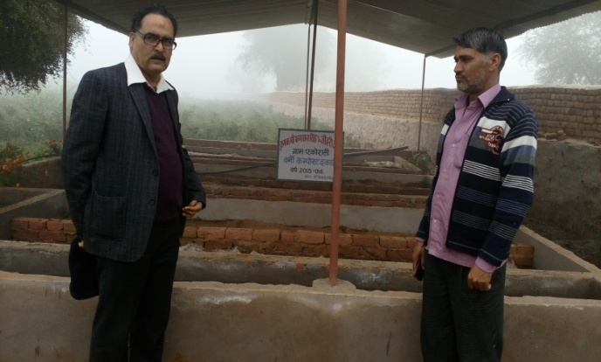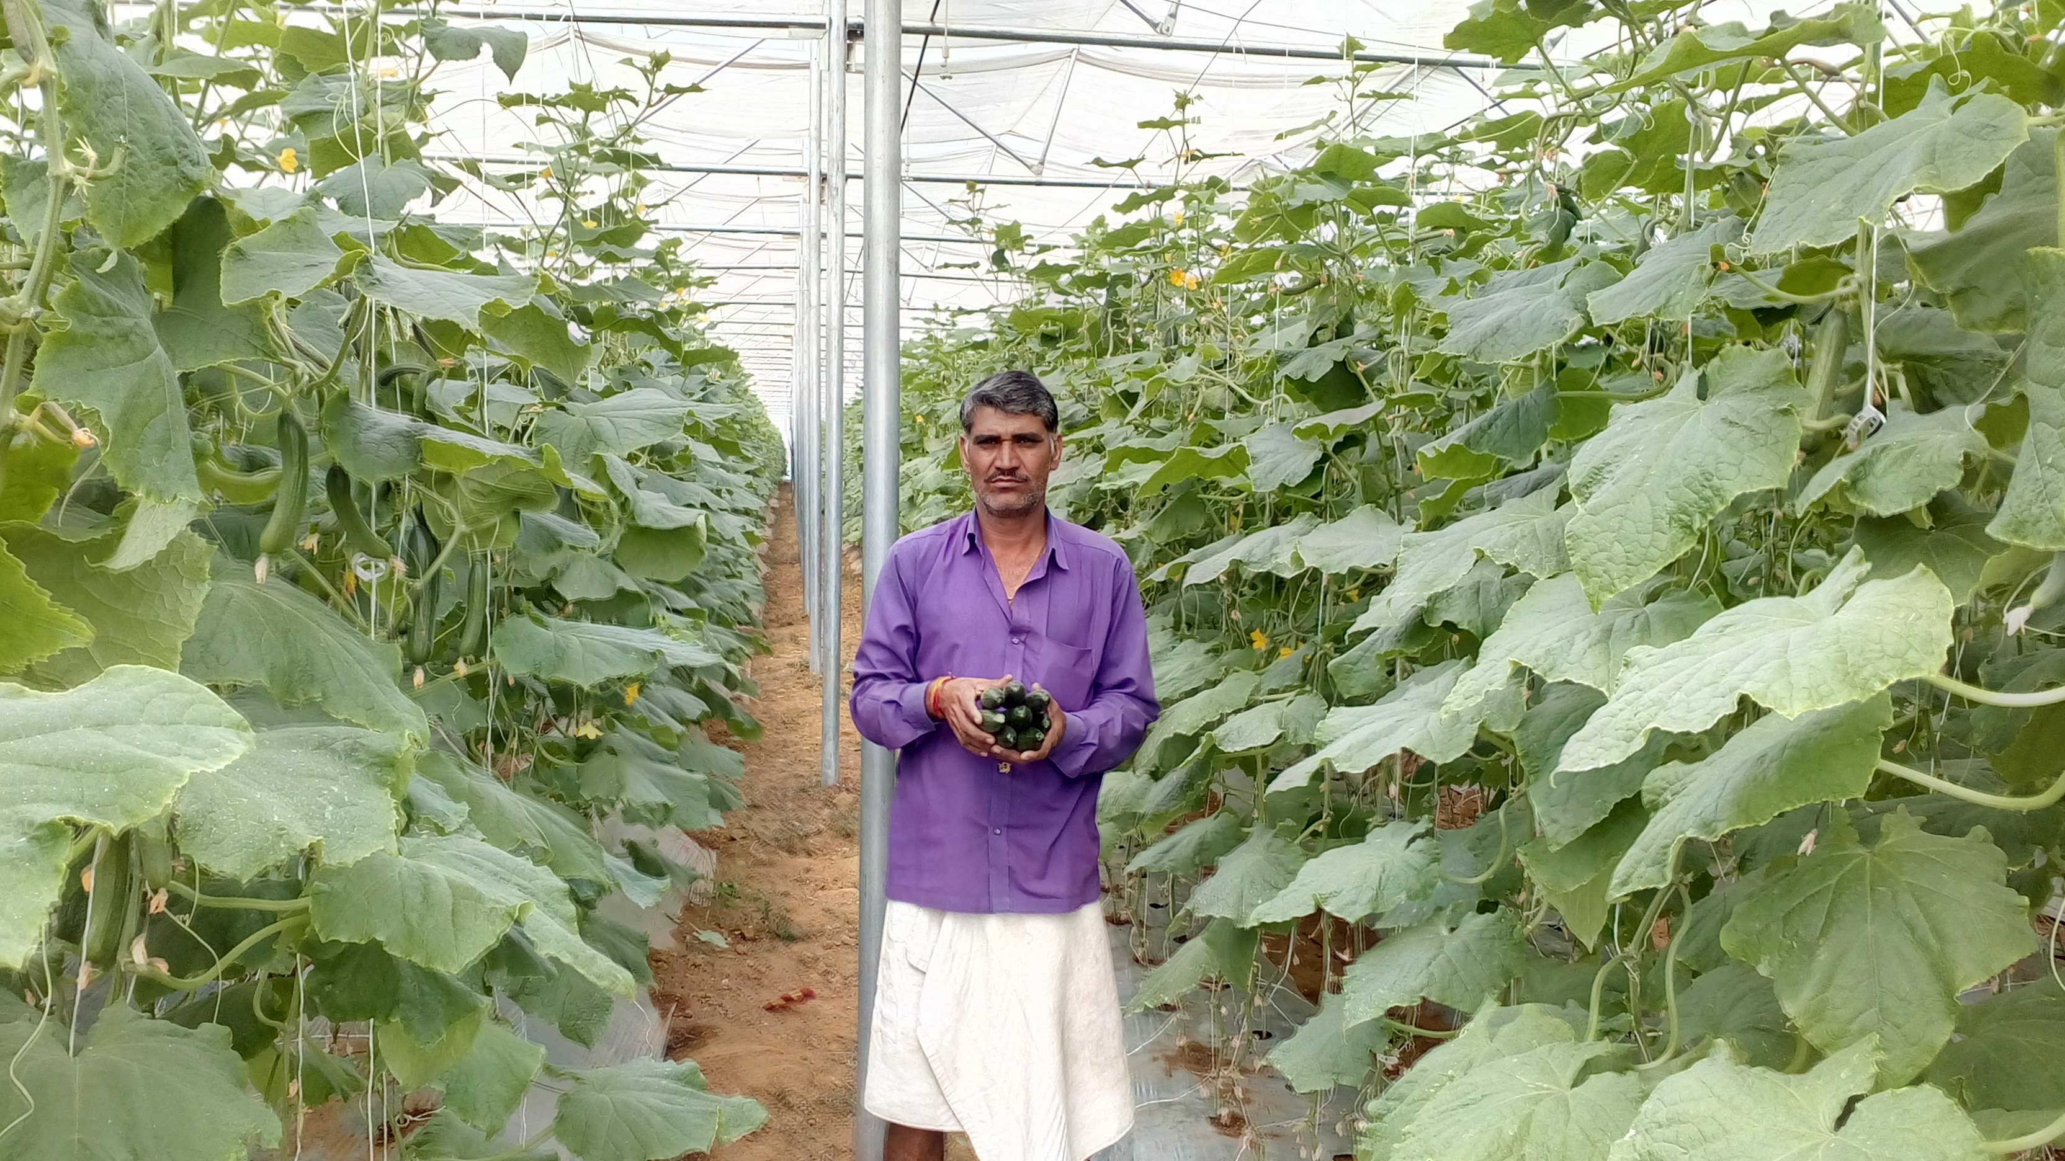
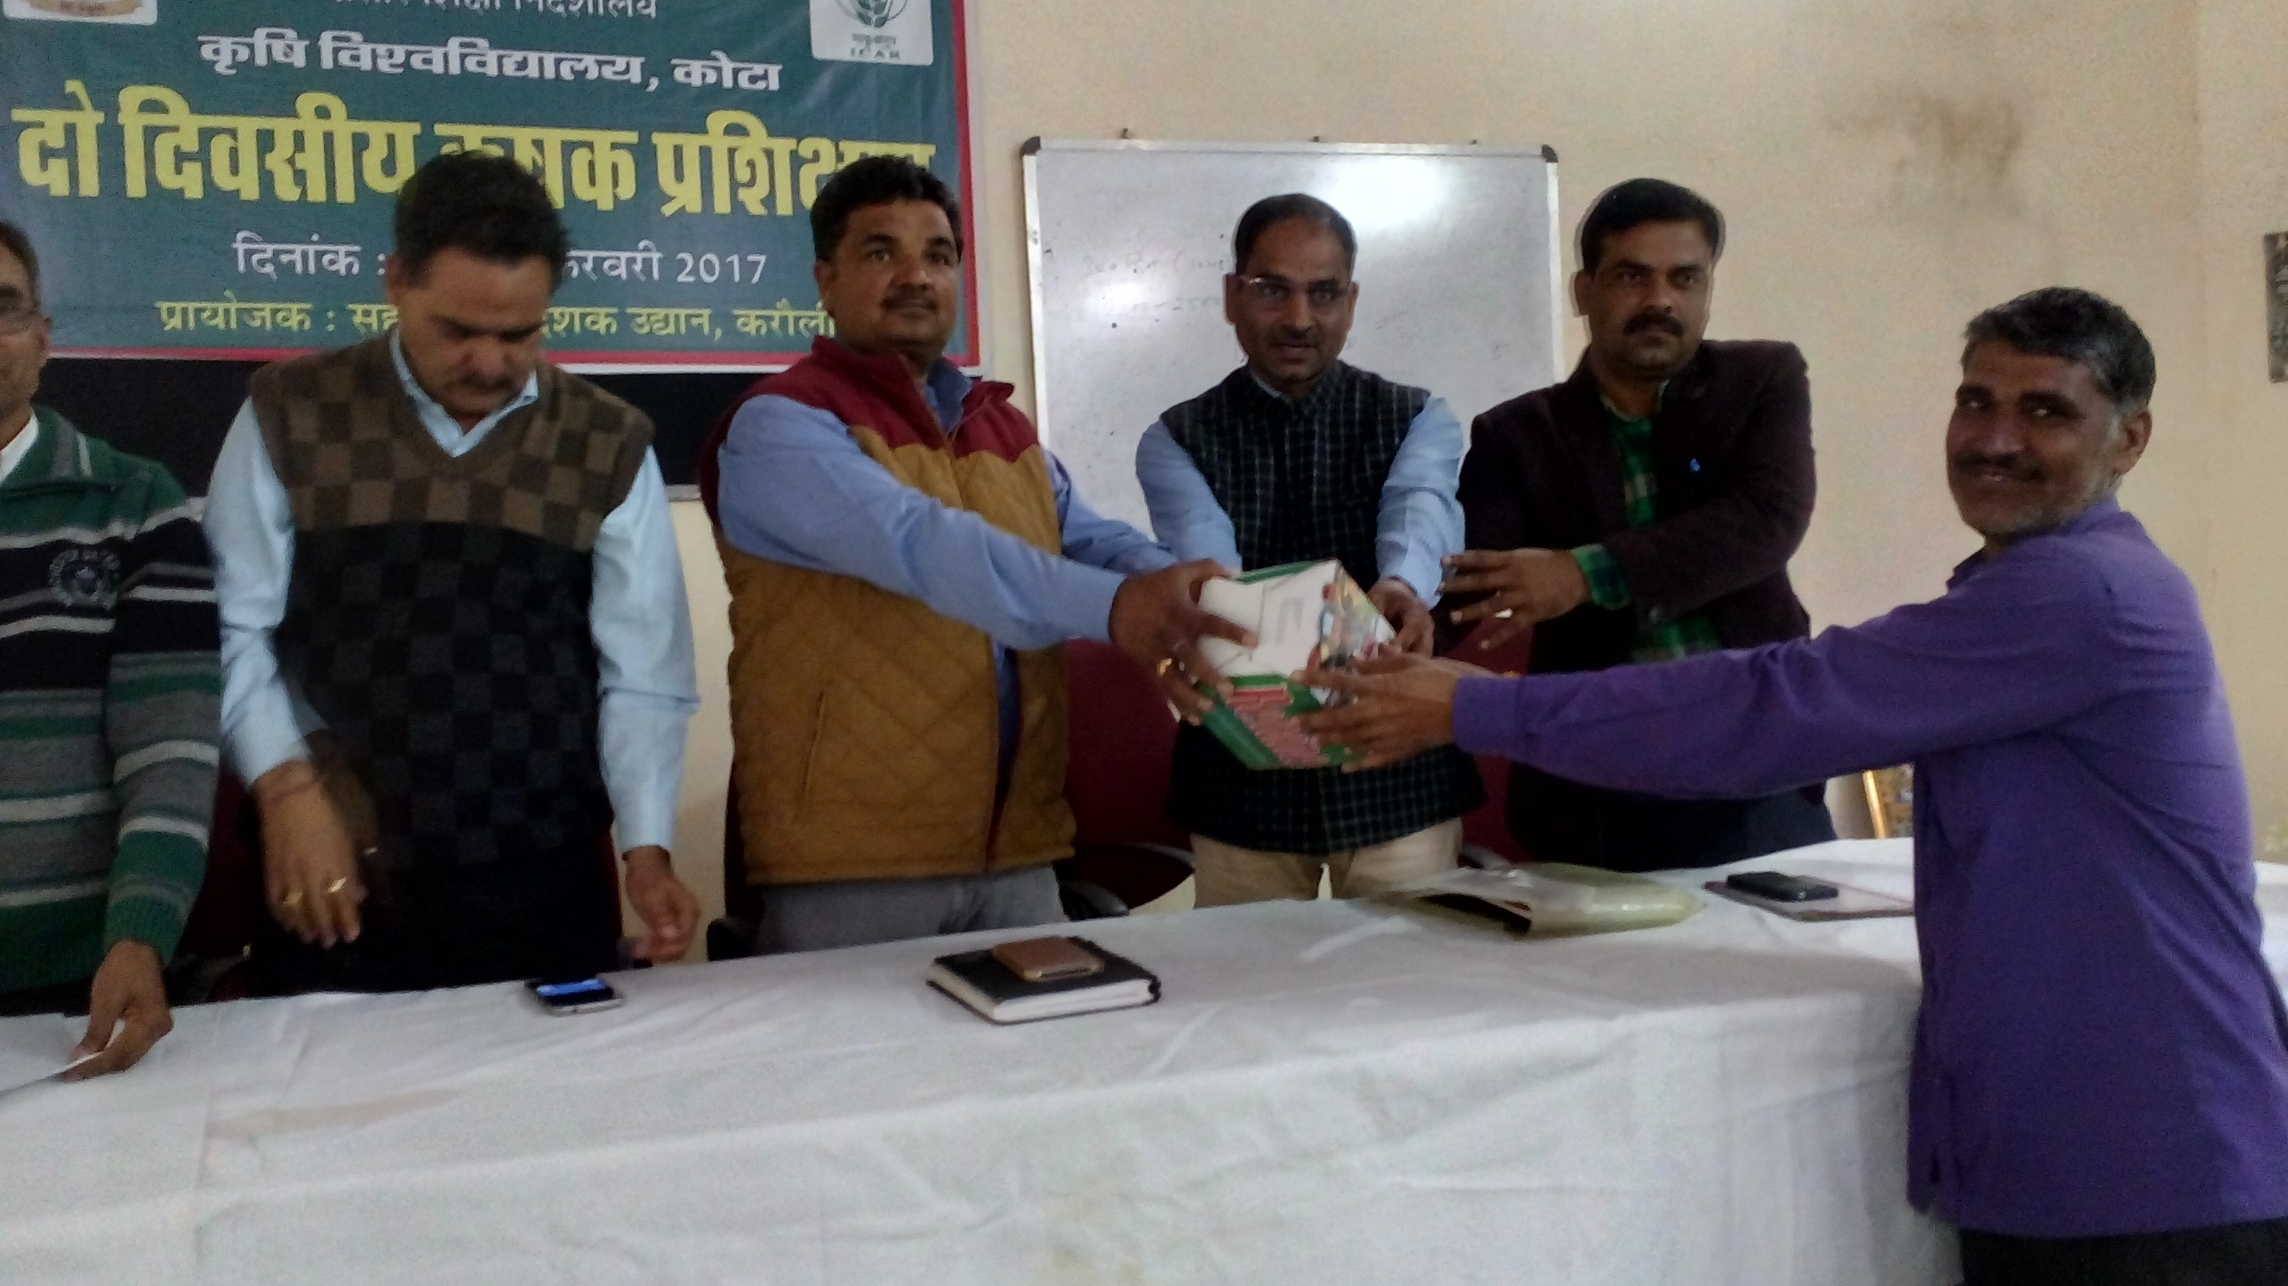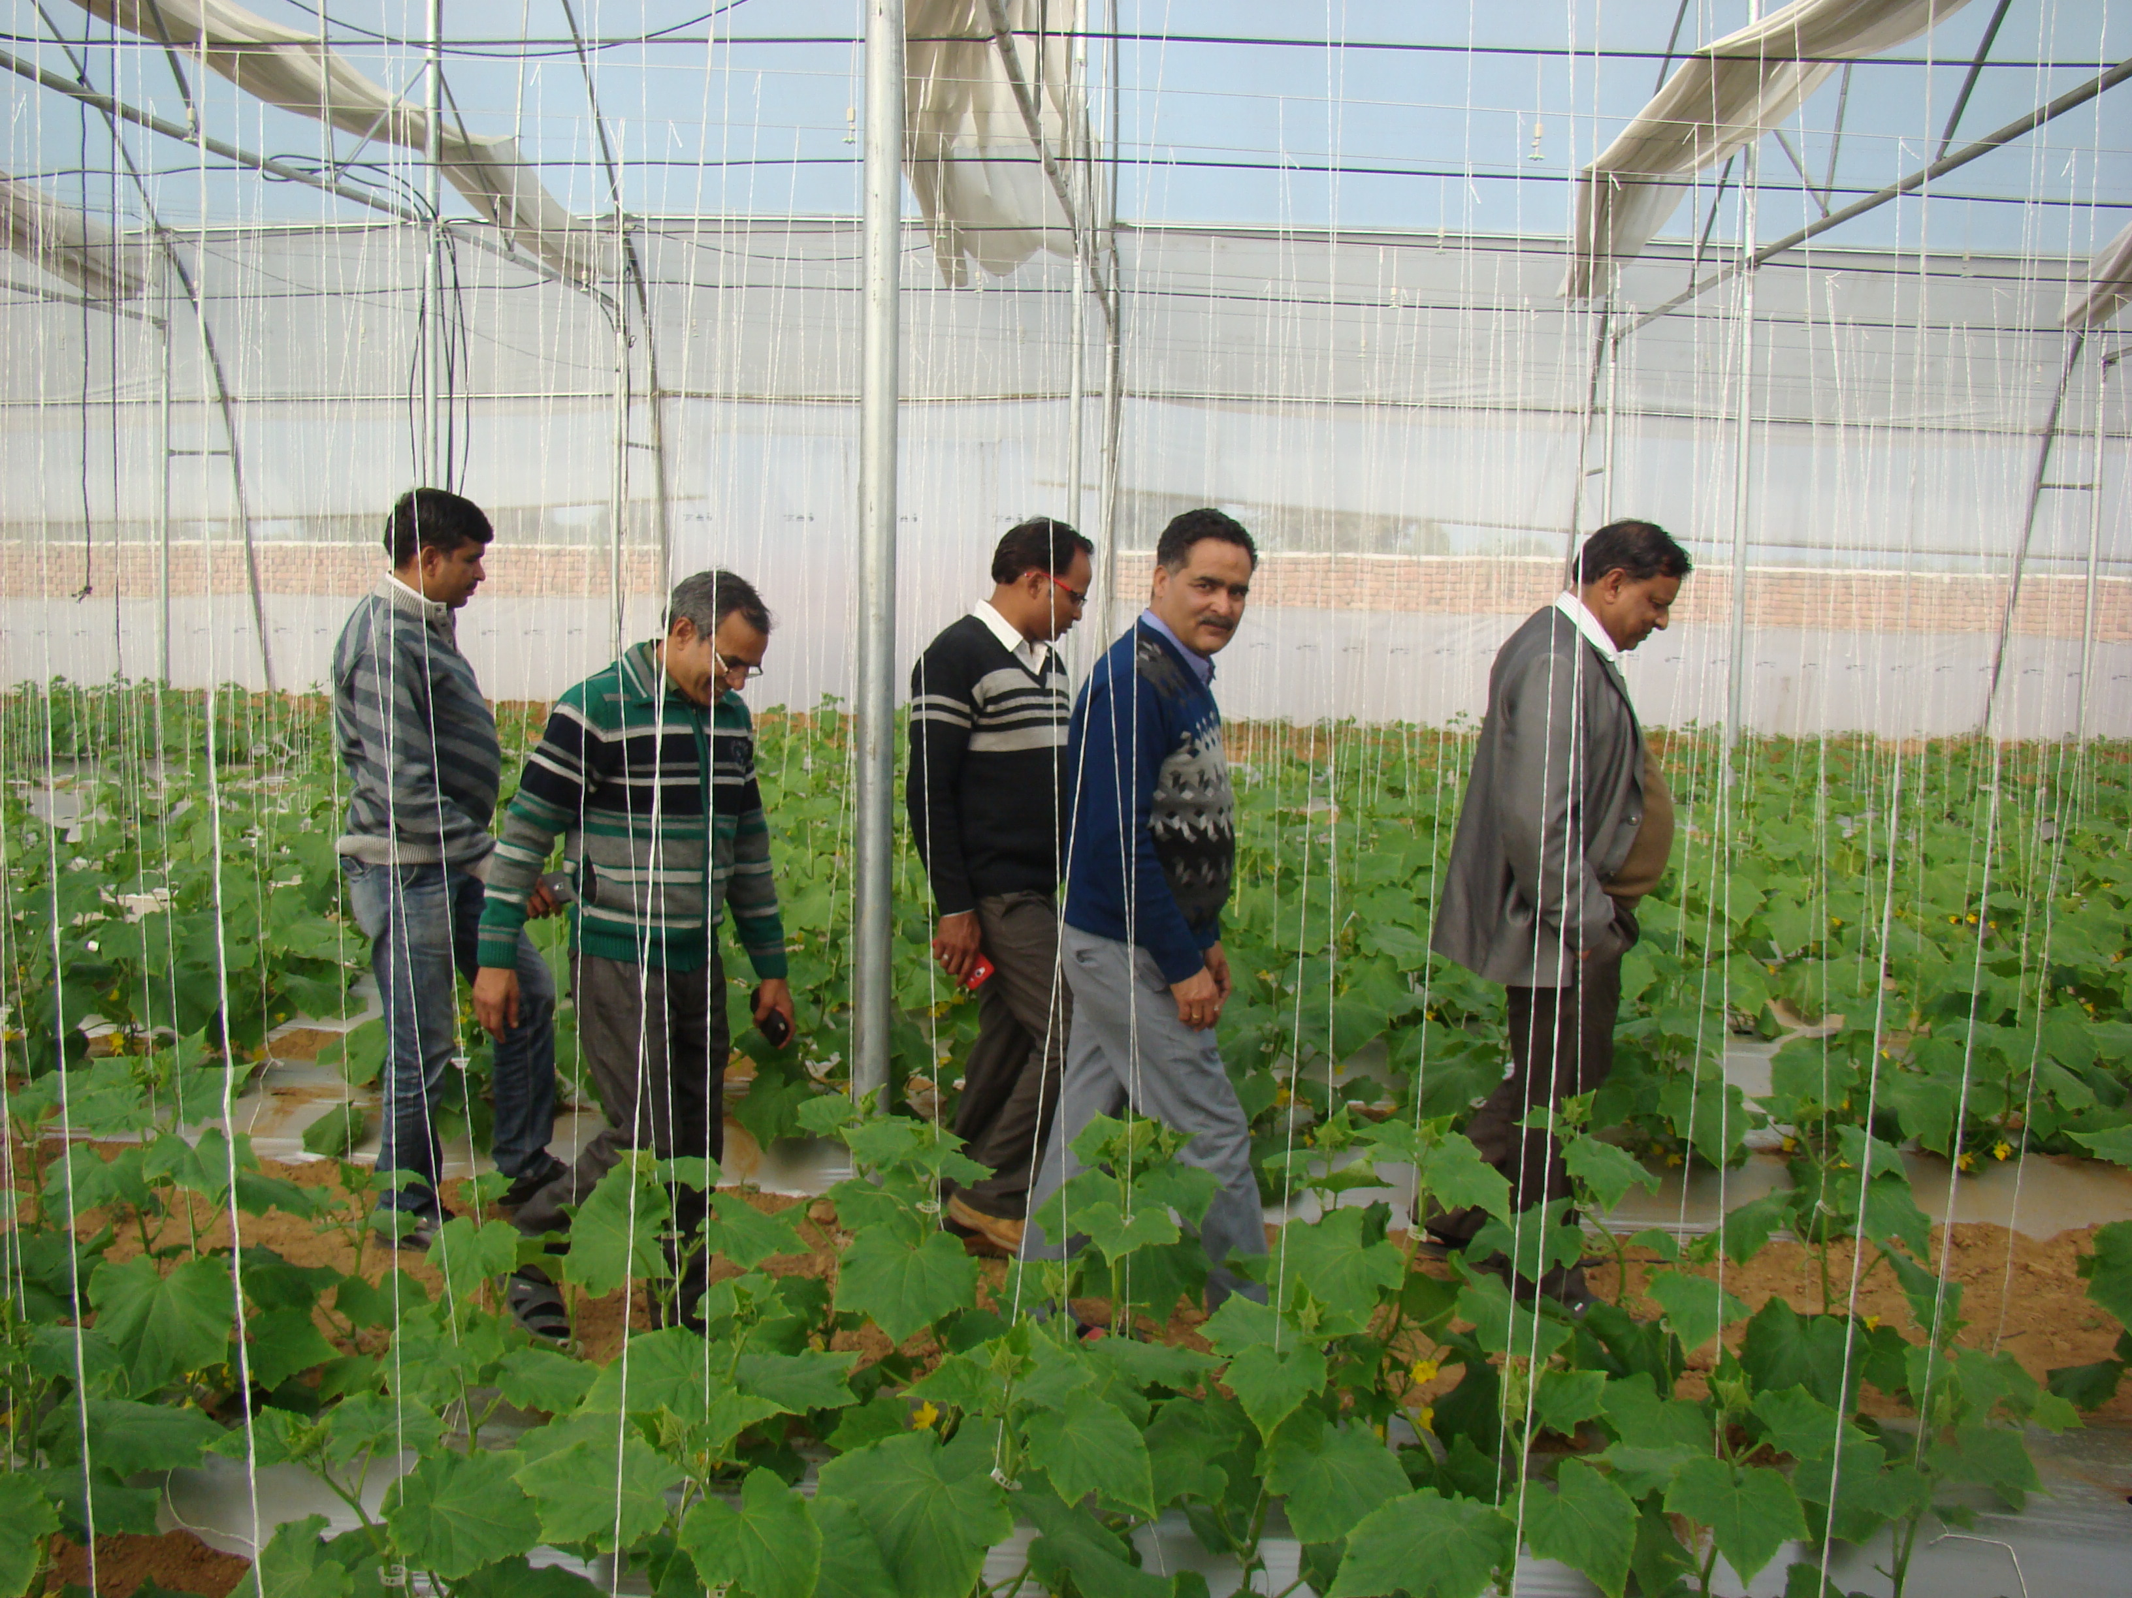

Collected and edited by: - Dr. R.K. Meena
Scientist Extension Education, KVK Hindaun (Karauli )

9. List special programmes undertaken by the KVK, which have been financed by State Govt./Other Agencies

Name of the scheme | Date/ Month of initiation | Funding agency | Amount (Rs.)
Nutri-Farm Pilot Project on Pearlmillet | 2014-15 | RKVY | 2,000,00=00
Krishak Mitra Training | 2014-15 | ATMA | 190000=00
Farmer Scientist Interaction | 2014-15 | ATMA | 40000=00
Nutri-Farm Pilot Project on Pearlmillet | 2015-16 | RKVY | 4,000,00=00
Farmer Scientist Interaction | 2015-16 | ATMA | 40000=00
Farmer Scientist Interaction | 2015-16 | ATMA | 40000=00
Nutri-Farm Pilot Project on Pearlmillet | 2016-17 | RKVY | 200000.00
Farmer Scientist Interaction | 2016-17 | ATMA | 60000.00
PPV&FRA | 2016-17 |  | 800000.00

10. Seminar/Workshop/Conference attended
S.no. | Name of programme | Duration | Organizing institute
 | 2014-15
1. | Zonal Workshop of KVKs | 24-26 May 2014 | Dantiwada Agriculture University, Dantiwada (Gujrat)
2. | Workshop on Nutri Farm Project | 07.07.2014 | DEE SKRAU, Bikaner
3. | Workshop organized by ZPD | 02.09.2014 | RARI Durgapura, Jaipur
4. | Meeting cum Workshop of KVKs | 29.10.2014 | Principal Secretary (Ag.) Govt. of Rajasthan, Jaipur
5. | 7th National Congress of Extension Education | 08-11 Nov. 2014 | Chairman, National Extension Education Society
6. | Winter School | 11 Nov. to 01 Dec. 2014 | Directorate of Rapeseed Mustard Research, Bharatpur
 | Winter School | 02-22 Dec. 2014 | MPUA & T, Udaipur
7. | Refresher Training Programme | 17-20 Dec 2014 | DEE SKRAU, Bikaner
8. | Workshop on Annual Action Plan 2015-16 | 24-25 Dec. 2014 | ZPD Zone-VI
9. | Winter School | 28 Jan. to 17 Feb. 2015 | IGFRI, Jhansi (U.P.)
10. | National Seminar | 26-28 Feb. 2015 | RMVRS Agriculture University Gwaliar (M.P.)
11. | Brain storming Workshop | 27-28 Feb. 2015 | Directorate of Extension Education, SKRAU Bikaner
 | 2015-16
12. | Workshop on pulse crops | 11-12Dec.15 | ICAR-ATARI,Jodhpur
13. | Zonal Workshop of KVKs | 23-25May,15 | DEE,MPUAT,Udaipur
14. | National Conference of KVK’s | 25-27 July 15 | Krishana Memorial, Patna (Bihar)
 | 2016-17
15. | National Conference on strategies& innovations in Ag.& Hort.Science | 26-27/4/2016 | Career point Univ.Kota
16. | Zonal Workshop of KVk’s Zone VI | 2-4/5/2016 | UAS,Anand
17. | Workshop cum training on pulses | 24-25/10/16 | Director ICAR-ATARI Jodhpur
18. | State level Mid Review & Planning workshop for KVK’s of Rajasthan | 07-08/12/16 | KVK, Vanasthali
19. | Winter School | 01-21/12/16 | Deptt. Of Ext.Education, RCA,MPUA&T Udaipur

11. Awards (Farmers/Scientist/Institution) NIL

12. Live/ demonstration units -Vermicompost

13.Other important activities (If any)
- City three phase electricity connection with the expenditure of Rs.11.00 lac in the month of Nov.16
- One tube well with the depth of 160 feet with the expenditure of 1.0 lac



